More Information:
TEL: +852-30697699
Email: mail@coeeb.org
Office hours:9:30-18:00(GMT+8)

COEEB 2024
Conference
Registration
Form

Kindly complete the following form to register for the COEEB 2024 Conference.

NOTE: Please make sure to submit these documents to conference email mail@coeeb.org.
1. final paper (doc. and pdf.) 2. completed registration form 3. payment proof

PERSONAL DETAILS (*required)
*Title | Prof. □ | Assoc. Prof. □ |  | Asst. Prof. □ |  | Photo Here
 | Dr. □ | Mr. □ |  | Ms. □
 | Lecturer □ | Ph.D Candidate □ |  | Postgraduate □
*Name
*Affiliation
*Nationality
*Phone Number
*Email
*Emergency Contact  (Second author) | (Name & Mobile)
Postal Address
Catering Service  (Onsite Conference)  (May 23, 2024)√ | Lunch □ |  |  |  | Dinner □
Special dietary√ | Diabetic □ |  | Vegetarian □ |  | Halal food □ |  | Other □  please specify:
Special requirements
(if any)

PAPER INFORMATION
*Paper ID |  |  |  |  | *Paper Pages |  |  |  |  |  | *Additional Page
*Paper Title
*Authors
*Who will be the presenter(Onsite Participation) |  |  |  |  |  |  |  |  | Additional Clarification(If any):
*Presentation Type√ |  |  | Oral □ |  |  |  | Poster □
Student ID No. (student only)
IAEEEE Member No.(member only)
*Receipt Issued to (usually refers to the person who paid the fee or the organization which will sponsor you to attend conference. If you will use the receipt for reimbursement purpose, we advise you to put your organization/company/affiliation name below):
REGISTRATION FEE (by US dollar)
ONSITE CONFERENCE
Submission Category | Category | Early  (Until Feb. 18, 2024) | Regular | On-site  (May 22-24. 2024) | Your Choice
Full Paper | Member Author | 550 USD | 600 USD | 650 USD
 | Regular Author | 600 USD | 650 USD | 700 USD
 | Student\Committee | 530 USD | 580 USD | 630 USD
Abstract | Member Presenter | 450 USD | 500 USD | 550 USD
 | Regular Presenter | 470 USD | 520 USD | 570 USD
 | Student\Committee Presenter | 420 USD | 470 USD | 520 USD

 | OTHERS
Extra Page/Per page | USD 50
Extra Paper Upload | USD 350
Extra Banquet Ticket | USD 70
Listener\Co-Author | USD 350
Extra Conference Proceeding | USD 100
Networking Event | TBD
Academic Visit Optional | TBD
·Notice
·Ordinary paper page is suggested no less than 4 pages. If the paper exceeds 5 pages, the additional pages will be charged.
·All the registered full papers will be published online.
·Onsite Conference—Full Paper Registration Fee covers: publication fee +meeting sessions on May 22-24, 2024 + 2 coffee breaks, 1 lunch, 1 dinner on May 23, 2024 + conference kits (Abstract Registration and Listener Registration will not cover the publication fee).
·For "No shows", registration fee is nonrefundable and the organizing committee shall not be liable for any compensation or refund.
·Shall the conference be delayed or prevented (directly or indirectly) by the reasons of natural disasters, war, strike(s), epidemic or any other events which could not be controlled, the organizing committee shall be under no liabilities. The organizing committee reserves the right to change the conference date, venue or form of the conference (online or on-site).
·Cancellation policy: Refund requests must fill the refund application form and e-mail to mail@coeeb.org. And for more details, please refer to the conference website: www.coeeb.org (On the registration page). For each refunded registration, a $100 cancellation fee will be debited from the refund.
·Our payment system will not charge any extra fee, but the credit card payment may incur currency exchange charge which is charged by the payers' bank, it should be borne by the payers.
PAYMENT INFORMATION
Online payment linkage (*VISA /Master is available. No handling fees, please calculate the amount and pay):
https://meeting.yizhifubj.com/web/index.action?meetingId=573
Please fill your E-mail address used for the payment and the Confirmation Number you received after paid.
E-mail:
Confirmation Number:
*As the system will intercept the email address for multiple payments, it is recommended to use different email for each payment.
IAEEEE MEMBER APPLICATION
Join IAEEEE now to qualify for member registration rates.
Please compile and return the Membership Form along with your CV to mail@coeeb.org. Your application will be processed in 5 working days.
Follow IAEEEE LinkedIn below for latest news.
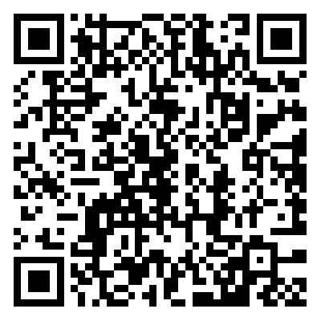
IAEEEE LinkedIn
COEEB 2024 Organizing Committee
Milan, Italy
More Information:
TEL: +852-30697699
Email: mail@coeeb.org
Office hours:9:30-18:00(GMT+8)

